HASIL RUNING CODE
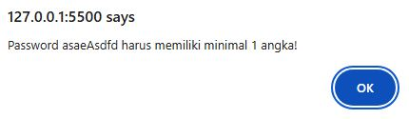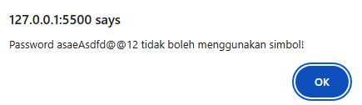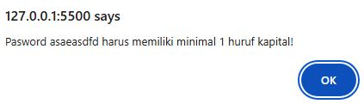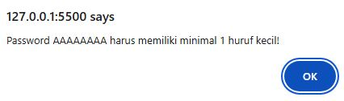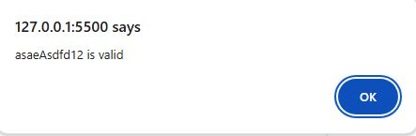

SYNTAX
function isValidPassword(password){
let passArr = password.split("");
let hurufBesar = "";
let hurufKecil = "";
let adaAngka = "";
let adaSimbol = "";
for(i = 0; i < passArr.length; i++){
let upper = isUpperCase(passArr[i]);
if (upper == true){
hurufBesar = passArr[i];
}
let lower = isLowerCase(passArr[i]);
if (lower == true){
hurufKecil = passArr[i];
}
let angka = cekNumber(passArr[i]);
if (angka == true){
adaAngka = passArr[i];
}
let simbol = cekSpecialCharacter(passArr[i]);
if (simbol == true){
adaSimbol = passArr[i];
}
}
if (password.length < 8){
alert(`Password ${password} harus mengandung minimal 8 karakter!`);
}else if(hurufBesar.length == 0){
alert(`Pasword ${password} harus memiliki minimal 1 huruf kapital!`);
}else if(hurufKecil.length == 0){
alert(`Password ${password} harus memiliki minimal 1 huruf kecil!`);
}else if(adaAngka.length == 0){
alert(`Password ${password} harus memiliki minimal 1 angka!`);
}else if(adaSimbol.length != 0){
alert(`Password ${password} tidak boleh menggunakan simbol!`);
}else{
alert(`${password} is valid`);
}
}
function isUpperCase (str){
let newStr = str.toUpperCase();
return str === newStr;
}

function isLowerCase (str){
let newStr = str.toLowerCase();
return str === newStr;
}

function cekNumber (input){
let number = `0123456789`;
let cek = number.includes(input);
return cek;
}

function cekSpecialCharacter (input){
let symbol = /[ `!@#$%^&*()_+\-=\[\]{};':"\\|,.<>\/?~]/;
let cek = symbol.test(input);
return cek;
}
// TEST PASSWORD
isValidPassword(`AAAAAAAA`);

